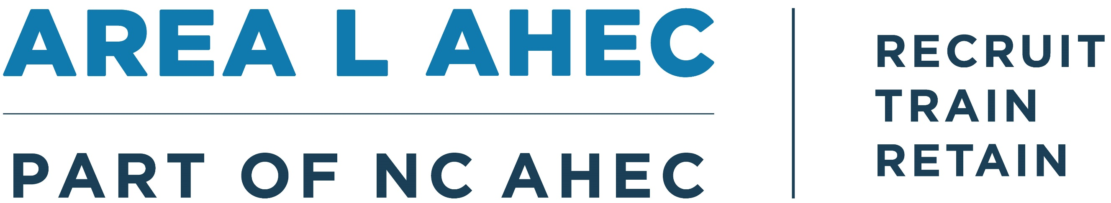

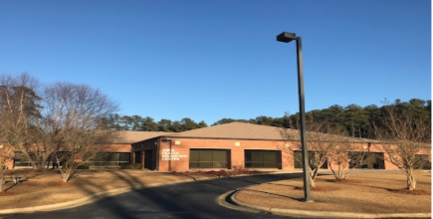
2024-2025 Year in Review
This year has brought significant challenges for Area L AHEC, including staff transitions and a restructuring of our finance department. While the process has not been easy, we are proud to have faced adversity head-on, learned from past experiences, and emerged with a stronger, more resilient foundation. Area L AHEC remains dedicated to delivering and supporting educational activities throughout our five-county region to recruit, train, and retain a strong healthcare workforce for a healthier North Carolina. This report provides an overview of our efforts, showcasing initiatives focused on educating and advancing the healthcare workforce.
Recruit
Health Careers & Workforce Diversity
Our Health Careers team provides meaningful learning experiences to prepare youth for future roles in their communities. Within Pathways, Area L AHEC hosted two field trips for high school students, featuring hands-on activities such as a fetal pig dissection, Stop the Bleed training, and substance use education. Area L AHEC also partnered with two education partnerships to provide programming to expose over 200 students to careers in health care through shadowing and engagement with local healthcare providers. Additionally, Jordan Blake, Director Health Careers, facilitated a group of UNC students and faculty that led health and wellness programming for campers ages 5–15 in Edgecombe County and who took part in a range of rural health experiences, including community engagement events, health center tours, a substance use recovery exhibit, EMS visits, and public health discussions—all aimed at deepening their understanding of rural healthcare delivery. In July 2024, the UNC Eshelman School of Pharmacy participated, and by June 2025, the initiative had grown into a fully interprofessional effort, engaging 18 students and 8 faculty from UNC’s Schools of Medicine, Nursing, Pharmacy, and Dentistry.

The Area L AHEC Scholars Program recruits, trains, and supports health professions students across its five-county region. In a milestone expansion beyond Wilson County, the program welcomed four students from North Carolina Wesleyan University in Nash County. Scholars shared how the program broadened their understanding of community health and inspired new career interests:

- “I enjoyed the spring conference because I was able to meet a lot of people, learn about different health facilities, and gain a sense of community in the process. I also enjoyed shadowing with Wilson EMS because it gave me practical information about health careers that are often overlooked. This has led me to consider the public health and community aspects of medical careers more seriously, which may ultimately shift my interests for my future career.”
- “I have gained more knowledge in how underserved communities need more accessibilities and deserve to have providers who care about their wellness.”

Train
Student Services
Our Student Services team successfully secured housing for 88 students during their rotation of community-based training. These students represented a diverse range of disciplines and schools, including UNC Pharmacy, Methodist PA, Campbell PA, Duke CRNA, Wingate PA, UNCG CRNA, ECU PA, High Point PT, UNC Medicine, Duke PA, High Point PA, UNC PA, UNC Nutrition and Dietetics, UNC Dentistry, and ECU NP.

The impact of these efforts is best captured in the words of a student: “My stay was great! Housing was located in a very safe & convenient location. The room was nice and included everything I needed like furniture, cleaning supplies, etc.”

CPD
Area L AHEC’s CPD service line has been working to develop a more tailored and targeted event calendar that better meets the needs of our regional constituents. At the same time, we are placing greater emphasis on financial efficiency to ensure maximum impact for every dollar spent. Our planning processes and procedures have been revised to align with these goals and create a streamlined workflow across all service lines. As a result of this restructuring, our CPD programming reflects a more strategic, though overall reduced, number of offerings.
As part of our outreach efforts, 80 senior nursing students participated in the course What the Heck is an AHEC, to learn more about our AHEC mission and future goals. We’re also excited to share that NC Wesleyan University (Rocky Mount, NC) has launched a nursing program, with our Nursing Director, Mrs. Patty Collins, proudly serving on its advisory board.
Statistics show that more than half of North Carolinians have experienced at least one form of emotional, physical, or sexual abuse—or another traumatic event—before age 18. In response, Area L AHEC is deeply committed to trauma education, Adverse Childhood Experiences (ACEs) awareness, and substance use disorder treatment, recovery, and prevention. This commitment has led to strong partnerships that supported the planning and delivery of four Recovery Coach Academy training courses and four Trauma & Resilience 101 courses. Additionally, 88 staff members at Camp Willow Run received ACEs education to ensure they were well-equipped, trained, and prepared to support every summer camper. In addition, we offered Controlled Substance prescriber CME and DEA-MATE–approved education for DEA registrants.

Retain
Practice Support (PS)
Our PS coaches are committed to helping regional practices enhance care delivery, improve quality, and reduce financial strain. While they continue to champion Medicaid managed care best practices, they also lead impactful initiatives across both the region and the state. Mrs. Becky Dixon, Practice Support Consultant, developed and led Job Coaching and Evaluations, a course offered within the NC AHEC Practice Manager Academy. In partnership with a team of PS coaches statewide, they designed and launched the Advanced Primary Care Model Toolkit which helps primary care practices deliver enhanced, continuous care through a value-based approach, linking reimbursement to patient complexity and risk stratification.
Our team has also met specialized training needs, providing Professionalism in the Workplace and HIPAA Policies & Record Destruction training for health departments in Halifax and Nash Counties. In collaboration with our CME department, our coaches developed and facilitated content for an asynchronous course, Transitions of Care Strategies: Improving Patient Outcomes and Reducing Readmissions.
Library Services
Library services were provided, as needed, to healthcare providers in the Area L AHEC region. In addition, an ad hoc group of NC AHEC librarians was led in a research project to support the statewide NC AHEC CPD service line.
Other
Statewide Projects
Area L AHEC is grateful for the strong, lasting partnerships we share with regional stakeholders, who entrusted our team to order, manage, and distribute supplies through the HRSA RCORP Impact grant. With their support, we placed 29 ONEboxes, emergency opioid overdose reversal kits, across Edgecombe, Nash, Wilson, and Wayne counties. In addition, through our Opioid Duke Endowment grant, we provided 20 Lockboxes to Halifax and Northampton counties; 36 boxes of Naloxone to Edgecombe, Nash, Halifax, and Northampton counties; 540 testing strips to Edgecombe, Halifax, and Northampton counties; and 9 ONEboxes to Halifax, Nash, Orange, and Durham counties.
We also had the opportunity to engage in exciting work around the Healthy Opportunities Pilots (HOP), the nation’s first comprehensive program to test and evaluate the impact of providing select evidence-based, non-medical interventions related to housing, food, transportation, and interpersonal safety/toxic stress to high-needs Medicaid beneficiaries. In collaboration with the Eastern AHEC Department of Nursing and Allied Health Education and Access East, we hosted three quarterly HOP meetings for Human Service Organizations (HSOs) participating in the program. In addition, we coordinated the planning and logistics for two asynchronous courses: Healthy Opportunities Pilot: Screening for Adverse Childhood Experiences for Care Managers and Healthy Opportunities Pilot (HOP) for the Care Manager: Understanding the Medical Respite Cross Domain Service.
From July through December 2024, Area L AHEC led three NC AHEC Learning Academy courses, reinforcing our shared commitment to equipping every NC AHEC team member with the education and resources needed to better serve communities across the state.
Health Talent Alliance – Talent Pipeline Management (TPM)
Area L AHEC remains steadfast in its commitment to healthcare workforce development. Despite transitions in the TPM position, our dedication has not wavered. Our team actively participates in workforce development meetings across the region and successfully reconvened the Health Care Advancement Coalition, a collaborative group of regional workforce development leaders. With the coalition’s support, we are now planning to host a Regional Healthcare Workforce Development Summit in November 2025.

